INTERESTS Module Specifications

# KENROY GAYLE – Senior Software developer

Table of Contents

KENROY GAYLE 1

OVERVIEW 1

Interest Dashboard 1

Functional on the dashboard screen 2

Filter interest records in data grid Section 2

Data grid view Section 4

Data grid view Buttons 5

New Interest Screen 7

# OVERVIEW

A module is that is used to maintain ‘Interests’. The screens below outline the module functionality.

Solution should be developed using C# .NET, SQL Server, Windows Forms.

P.S. To accurately test this application please ensure all the SQL objects are executed in sql server and update the app.config connection string

# Interest Dashboard

When the application starts ups the screens below is shown, which the Interest Module main Screen.

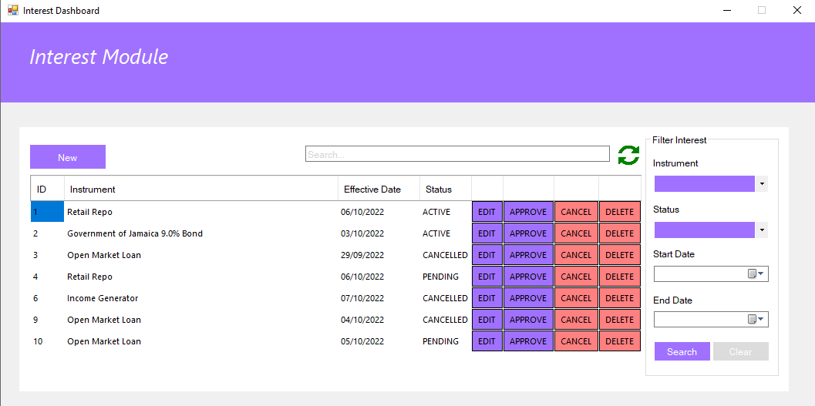

# Functional on the dashboard screen

Display the interest records in a data grid

## Filter interest records in data grid Section

The filter Section of the dashboard filter the result on the following fields

* ins_code
* Status
* Effective_date (start and end date)

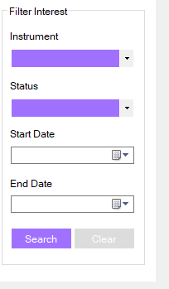 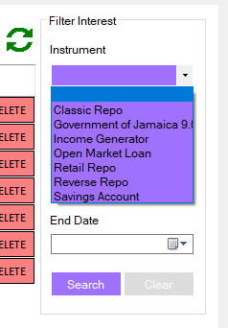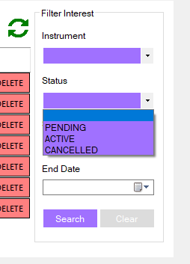 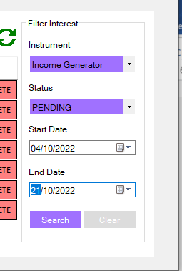

Search button filters out the data based on selections based on the fields populated, the clear button unsets all the filters and reload the data grid

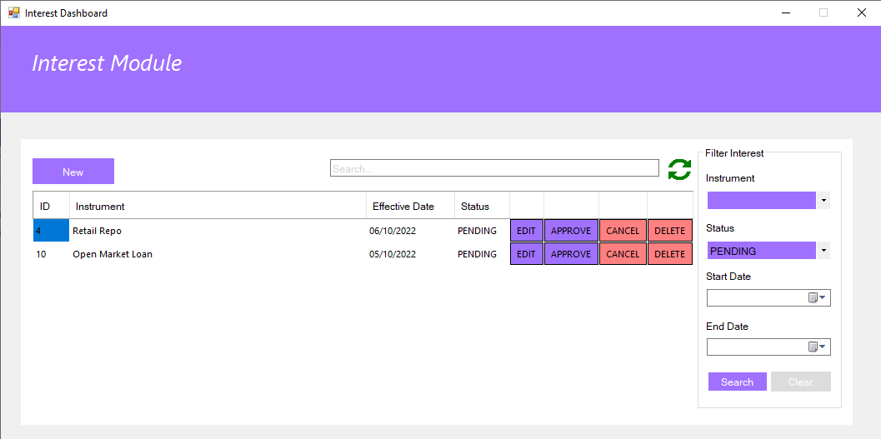

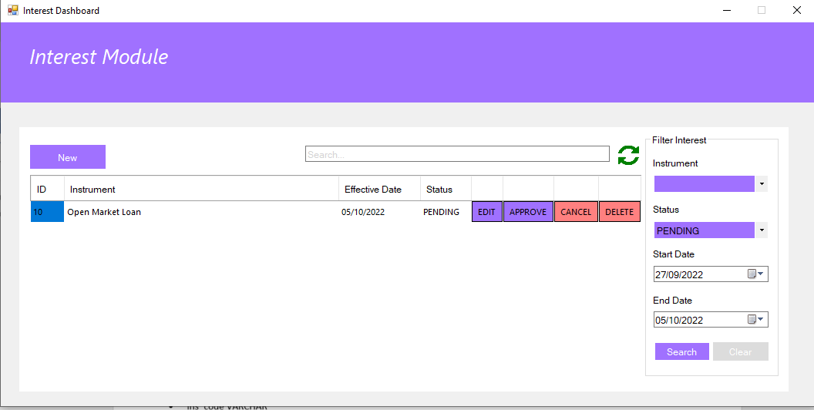

## Data grid view Section

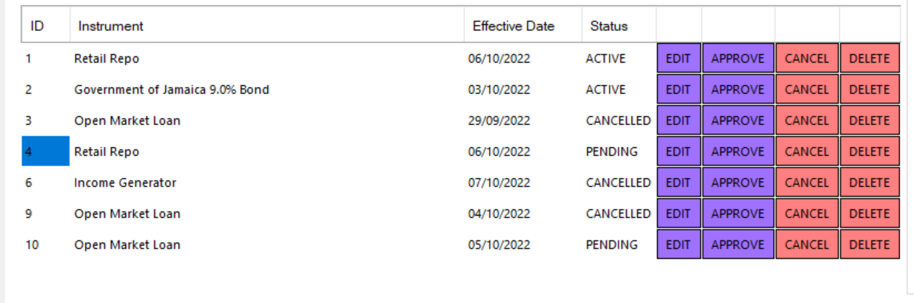

Displays the results in a tabular format, the following fields are should in the grid:

* ID
* Instrument
* Payment Date
* Status
* Edit
* Delete
* Approve
* Cancel

### Data grid view Buttons

EDIT – Will only open the edit window for Pending records

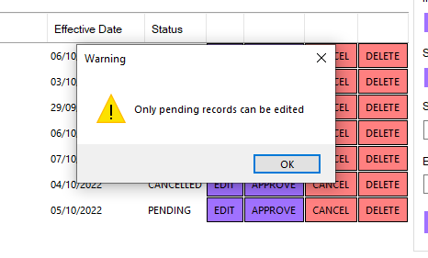

#### Edit Interest Screen

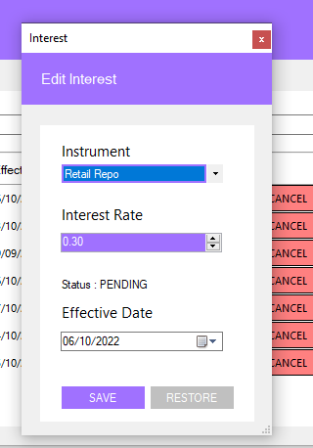 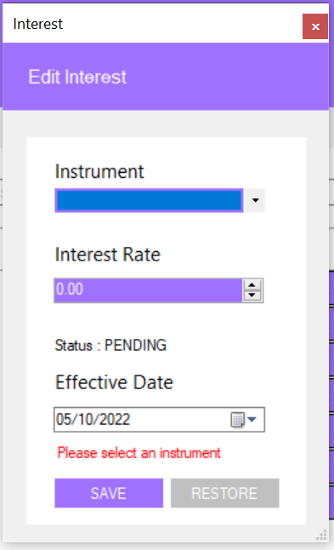

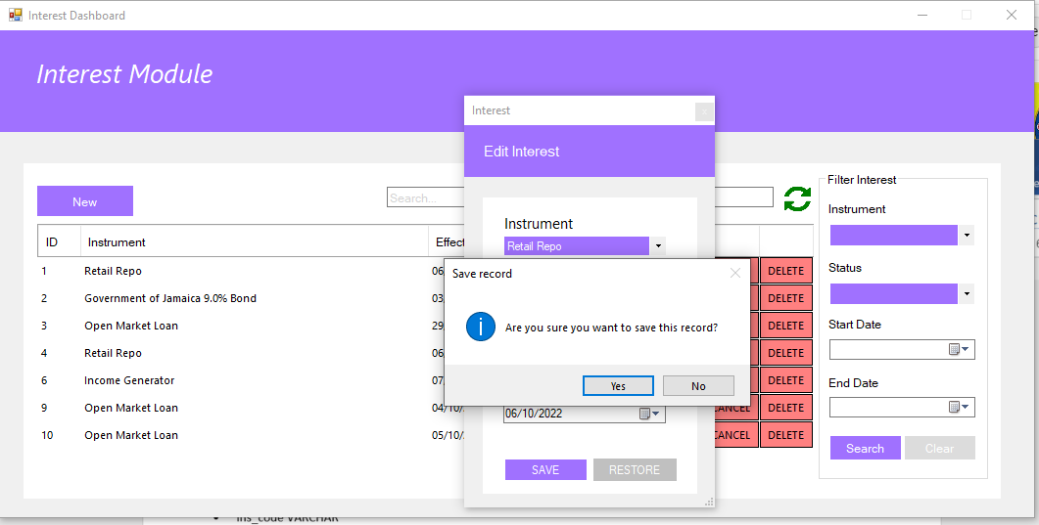

Press the save button on the edit screen to validate the users selection and update the record in the database

Pressing the RESTORE button on the edit screen will restore the original data

#### DELETE - Will only delete for Pending records

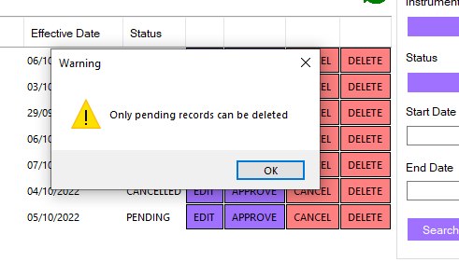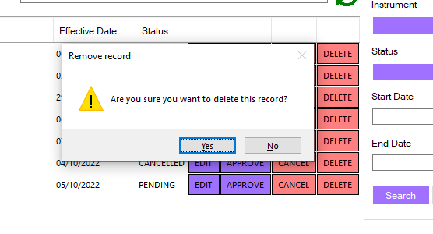

#### APPROVE – Will only approve for pending records

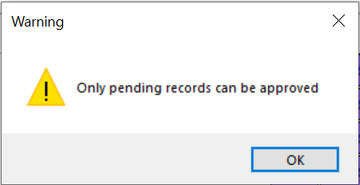 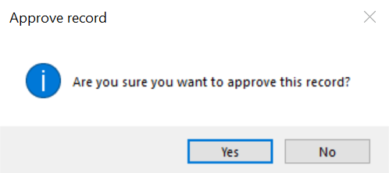

#### CANCEL - Will only cancel for active records

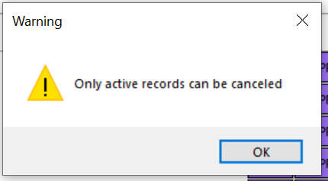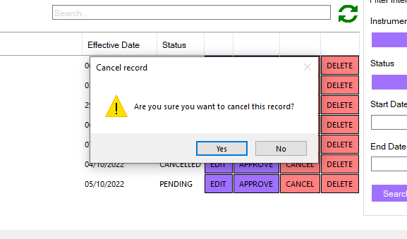

How popups are disabled

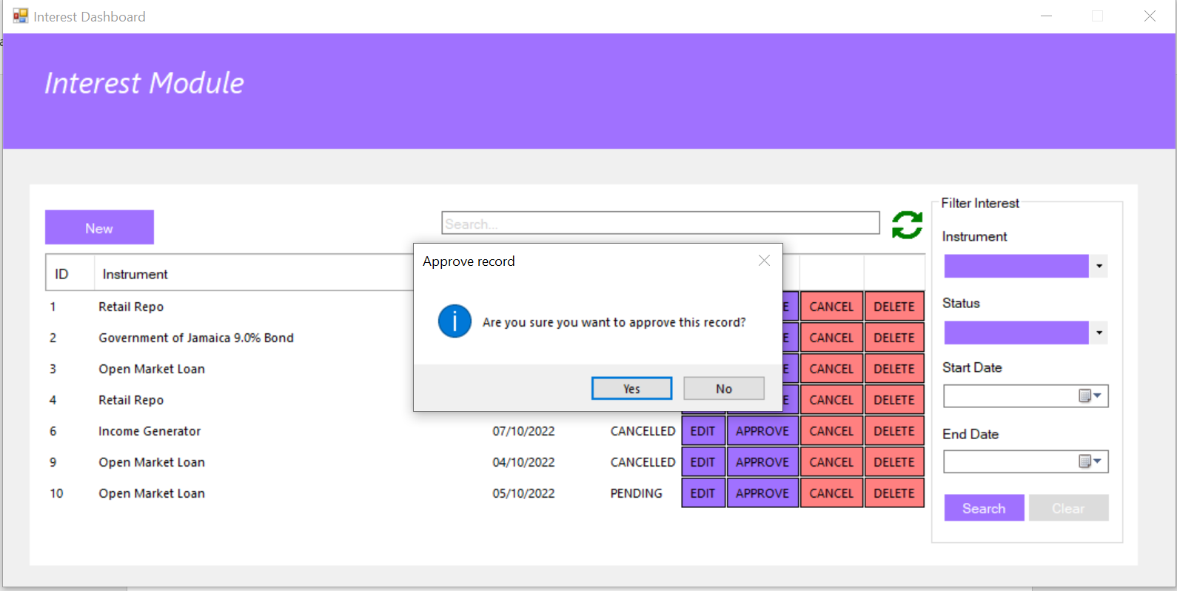

# New Interest Screen

Select the new button on the Interest Dashboard

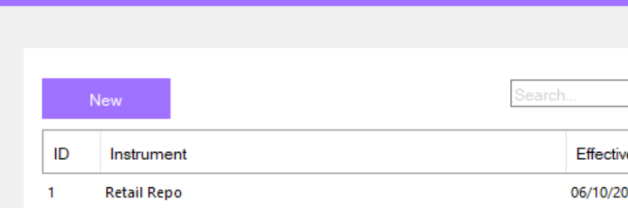

New Interest Screen – All fields will be blank when the screen just pops up.

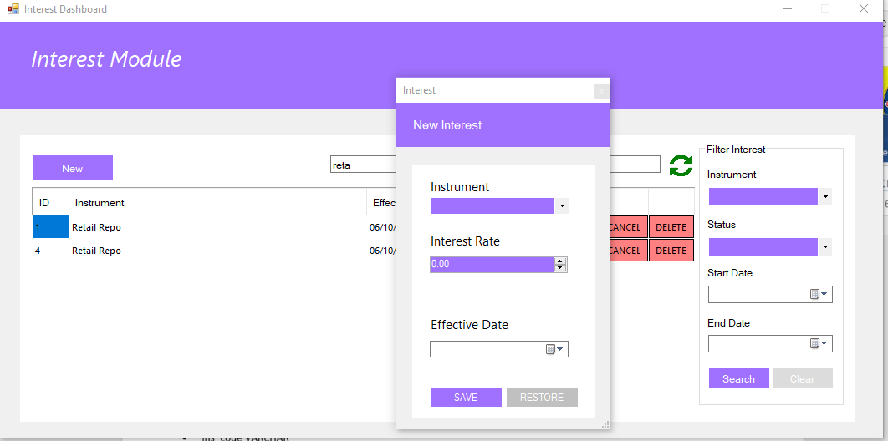

Validation is done when the user presses the save button.

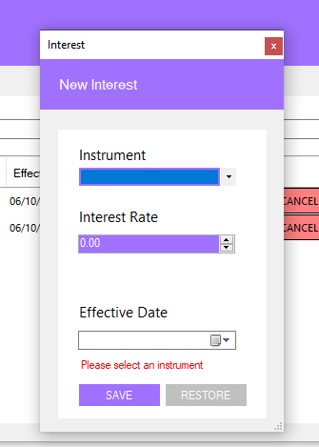 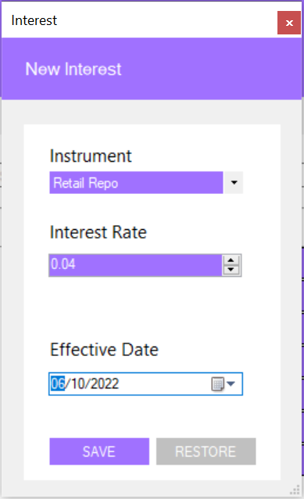

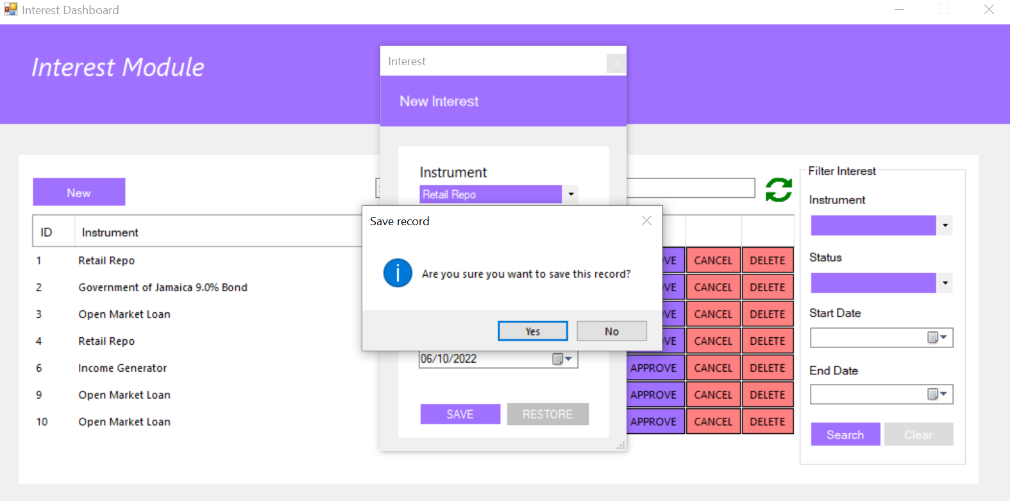

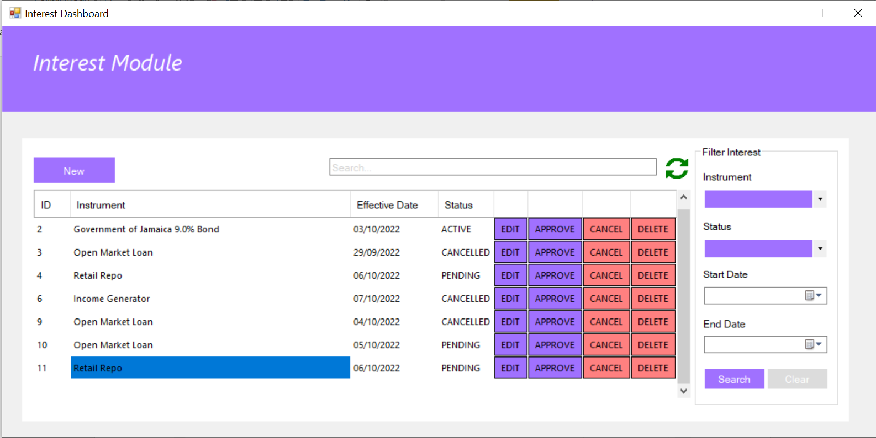

#### Search section

Search field – This field is used to search the result in the data grid based on the columns ID,Instrument, and Status field

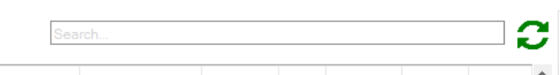

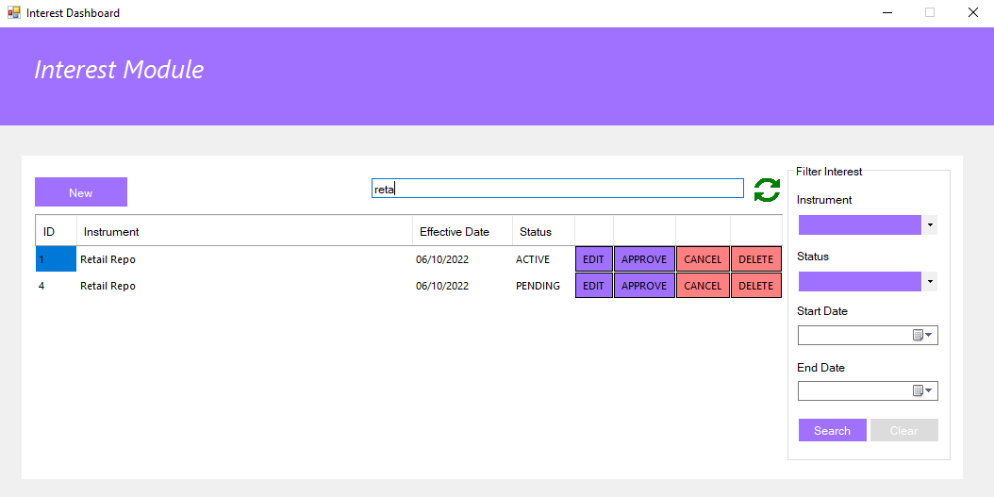

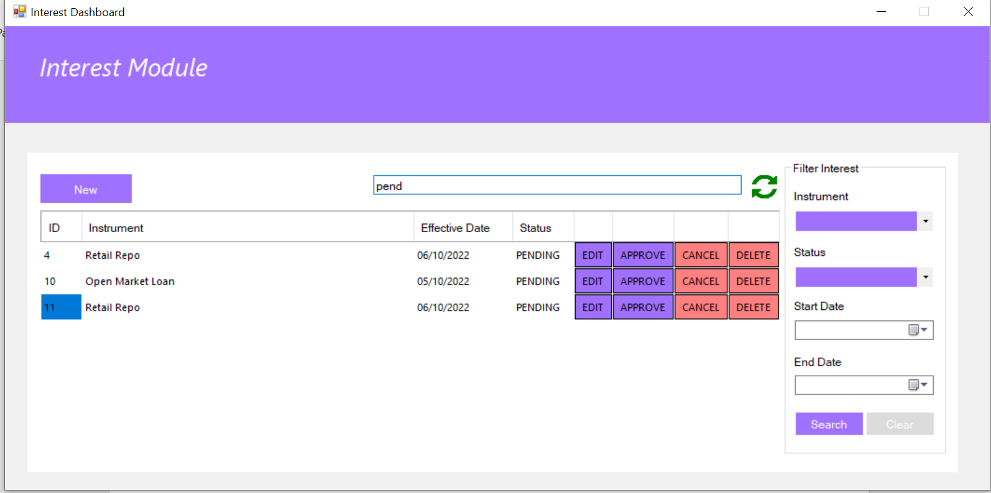

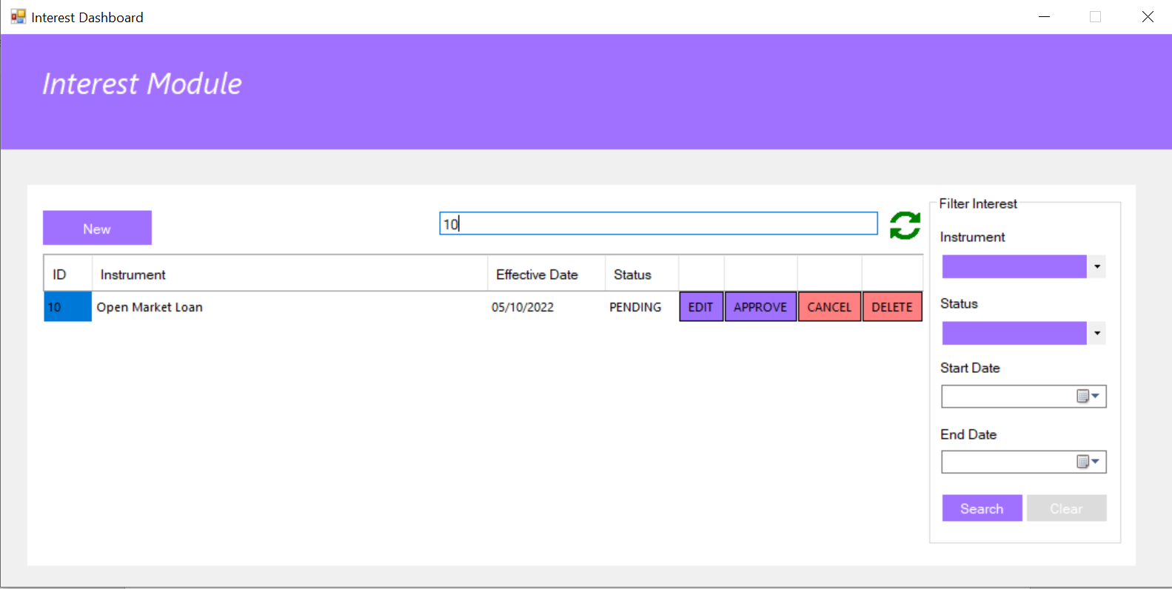

Reload Button – this is used to reload the data in the grid view

